Electron configuration

Syllabus points

- Atoms can be modelled as a nucleus, surrounded by electrons in distinct energy levels, held together by electrostatic forces of attraction between nucleus and electrons; the locations of electrons within atoms can be represented using electron configurations

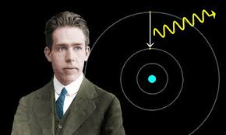
- The Bohr Model of the Atom

Niels Bohr proposed the following
- Electrons revolve around a fixed nucleus in circular orbits
- The electrons' orbit corresponds to specific energy levels (shells) in atoms
- Electrons can only occupy these fixed energy levels. They cannot exist between two energy levels
- Electron orbits of larger radii correspond the energy levels of higher energy

The region of space an electron occupies is the electron shell
The shell corresponds to a fixed amount of energy
Any electron in that shell has that amount of energy or energy level

Electrons can move between energy levels by absorbing or emitting energy in the form of light.

Although, this model is able to explain the patterns of electrons for the first 20 elements

3.1 review key questions (p.46)

- Electron Configuration

- Electrons in an atom are arranged in shells and the shells hold different numbers of electrons
- Electrons are as close to the nucleus as possible
  - Therefore occupy the inner shells before the outer shells
- Electron configuration is the number of electrons in each shell, separated by commas, starting at the shell with the lowest energy (closest to the nucleus)
- The maximum number of electrons able to fill each shell for the first 20 elements is as follows: 2, 8, 8, 2

Eg: Sulfur

Sulfur has an atomic number of 16
= 16 protons
= 16 electrons

2, 8, 6

Your turn: Argon

Ions
- The element will have the same number of protons but different number of electrons
- If an atom loses an electron --> positively charges (cation)
- If an atom gains an electron --> negatively charged (anion)
- This will change its electron configuration

Sodium Sodium ion
Atomic number = 11 atomic number = 11
= 11 protons + 11 electron = 11 protons
but 10 electrons

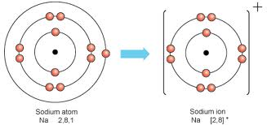

- Notice that ions form a configuration similar to the Nobel gases
  - This is the octet rule

3.2 review key questions (p.52)
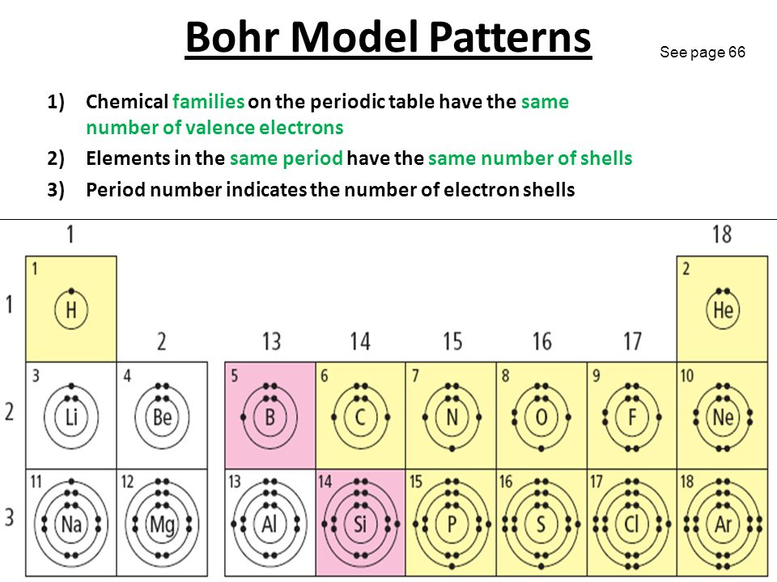
- Extension - shells and subshells

- Electron shells consist of subshells with different shapes
  - s, p, d, and f
- The subshells consist of orbitals that each hold 2 electrons
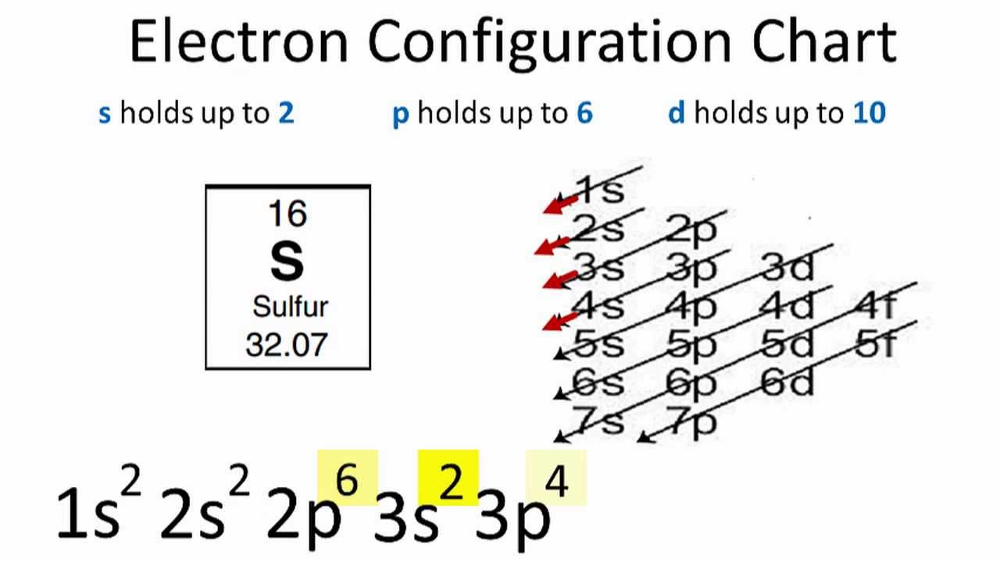

Vocabulary words

- Atom
- Proton
- Neutron
- Electron
- Nucleus
- Nucleon
- Element
- Atomic number
- Mass number
- Isotope
- Relative atomic mass

